Logbook: project/paper sele_dcdc

The objective of this prohject is to implemente a dc/dc converter, using a three-phase interleaving structure.

This work is a result of academic work of master students framed in electronics course of integrated master in electrical and computers engineering.

This document is aging from end to beginning (the #1 task is the most recent)

# Tasks

1. Proposed software and hardware
   1. 2x converters; one of them in voltage control; the other in current control
2. Hardware setup design
3. Software “get2know”
   1. Load to my ws
   2. Divide into blocks

# Partial results

## Proposed HW and SW

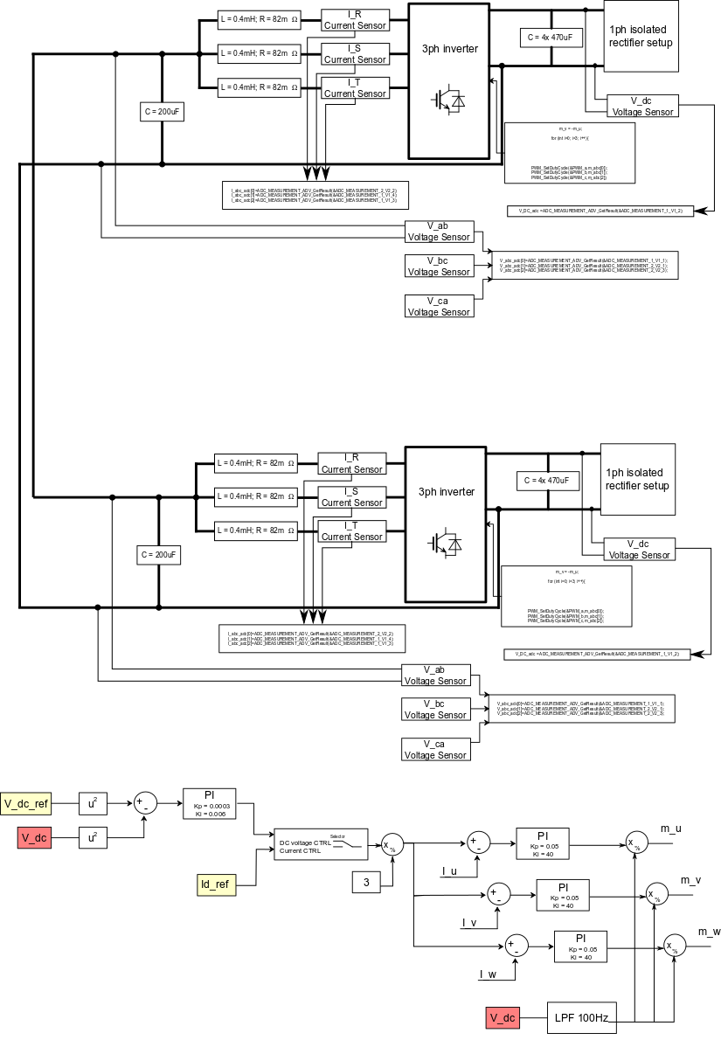

One of the converters must operate in DC voltage control and the other converter will test the DC voltage loop

## Implemented hardware:

The implemented hardware is presented as following

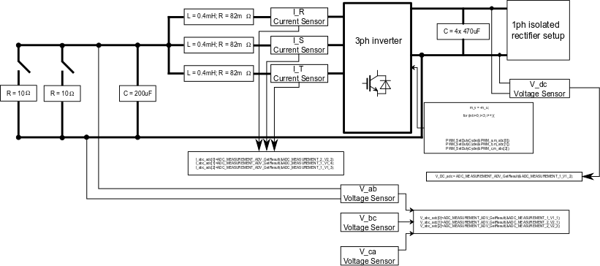

## Implemented software: